SQL BASICS

Used : SQL work bench

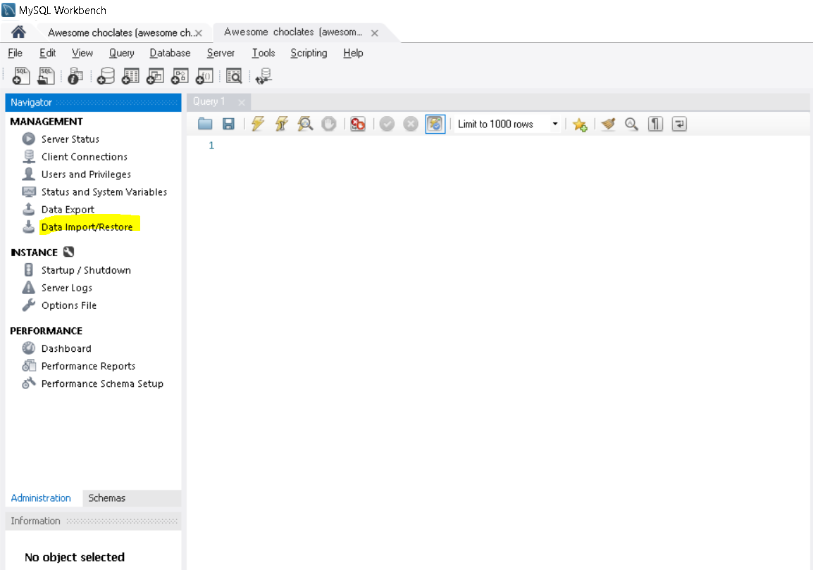

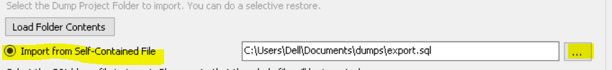

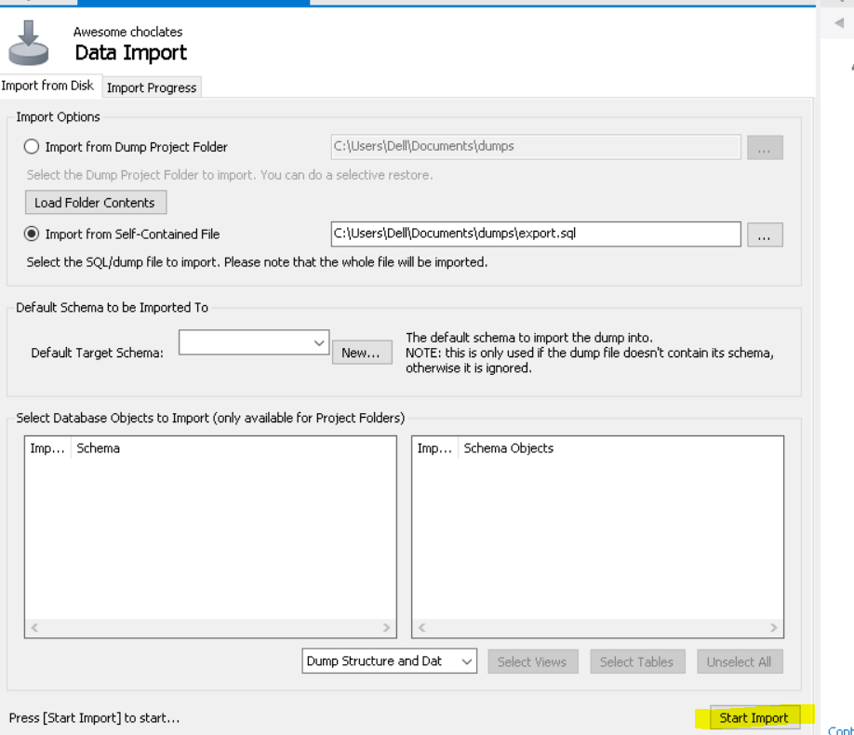

These are the steps to import any data files into my sql work bench